第6章 广播接收者——应用案例

案例6-1 CallRecord（通话记录）

一、案例描述
- 考核知识点
030006001：广播接收者简介
030006002：广播接收者的创建
- 练习目标
- 广播的静态注册和使用
- 使用广播处理处理事件
- 需求分析
手机最重要的功能就是通话功能，同样储存通话记录也是必不可少的。该案例使用广播接收者自己实现通话记录的功能。包括呼出电话、已接来电、未接来电以及通话产生的时间。
- 设计思路（实现原理）
- 注册监听电话状态的广播；
- 在广播的onReceive()方法中使用SQLite记录通话记录；
- 将通话记录展示在ListView上。

二、案例实现
（1）创建第一个界面
创建一个名为“CallRecord”的程序并创建第一个界面MainActivity，该Activity用于展示已拨、已接和未接来电，程序主界面如图6-1所示。
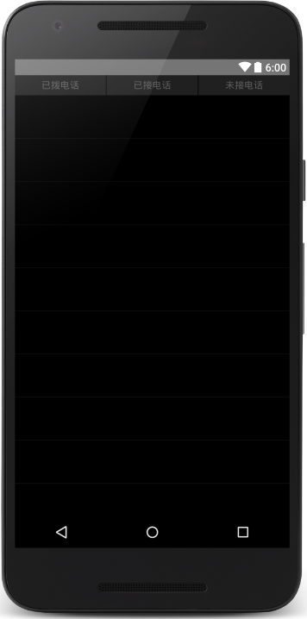
- 主界面
MainActivity界面对应的布局文件（activity_main.xml）如下所示：
<?xml version="1.0" encoding="utf-8"?>
<RelativeLayout xmlns:android="http://schemas.android.com/apk/res/android"
xmlns:tools="http://schemas.android.com/tools"
android:layout_width="match_parent"
android:layout_height="match_parent"
android:background="#000000"
tools:context=".MainActivity" >
<LinearLayout
android:id="@+id/ll_title"
android:layout_width="match_parent"
android:layout_height="wrap_content"
android:background="#212021"
android:orientation="horizontal"
android:weightSum="3" >
<RelativeLayout
android:id="@+id/rl_dialedCalls"
android:layout_width="wrap_content"
android:layout_height="match_parent"
android:layout_weight="1" >
<TextView
android:id="@+id/tv_dialedCalls"
android:layout_width="wrap_content"
android:layout_height="wrap_content"
android:layout_centerInParent="true"
android:text="已拨电话"
android:textColor="#5a5d5a" />
</RelativeLayout>
<View
android:layout_width="1dp"
android:layout_height="30dp"
android:layout_gravity="center_vertical"
android:background="#000000" />
<RelativeLayout
android:id="@+id/rl_receivedCall"
android:layout_width="wrap_content"
android:layout_height="match_parent"
android:layout_weight="1" >
<TextView
android:id="@+id/tv_receivedCall"
android:layout_width="wrap_content"
android:layout_height="wrap_content"
android:layout_centerInParent="true"
android:text="已接电话"
android:textColor="#5a5d5a" />
</RelativeLayout>
<View
android:layout_width="1dp"
android:layout_height="30dp"
android:layout_gravity="center_vertical"
android:background="#000000" />
<RelativeLayout
android:id="@+id/rl_missedCall"
android:layout_width="wrap_content"
android:layout_height="match_parent"
android:layout_weight="1" >
<TextView
android:id="@+id/tv_missedCall"
android:layout_width="wrap_content"
android:layout_height="wrap_content"
android:layout_centerInParent="true"
android:gravity="center_horizontal"
android:text="未接电话"
android:textColor="#5a5d5a" />
</RelativeLayout>
</LinearLayout>
<ListView
android:id="@+id/listview"
android:layout_width="match_parent"
android:layout_height="match_parent"
android:layout_below="@+id/ll_title"
android:divider="#313431"
android:dividerHeight="1px" />
</RelativeLayout>
（2）创建数据库
在项目中创建一个包，命名为db，并创建一个数据库类，用于储存通话记录，具体代码如下：
- package cn.itcast.callrecord.db;
- import android.content.Context;
- import android.database.sqlite.SQLiteDatabase;
- import android.database.sqlite.SQLiteOpenHelper;
- public class SQLiteHelper extends SQLiteOpenHelper {
- public SQLiteHelper(Context context) {
- super(context, "CallRecords.db", null, 1);
- }
- @Override
- public void onCreate(SQLiteDatabase db) {
- db.execSQL("create table phone (id integer primary key autoincrement," +
- "phone varchar(20)," +
- "classify varchar(20)," +
- "date varchar(20))");
- }
- @Override
- public void onUpgrade(SQLiteDatabase db, int oldVersion, int newVersion) {
- }
- }
（3）创建业务bean
在项目创建一个包，命名为bean并在其中创建一个业务类Phone，其中包含phone、date、classify三种属性，具体代码如下所示：
- package cn.itcast.callrecord.bean;
- public class Phone {
- private int id;
- private String phone;
- private String classify;
- private String date;
- public String getDate() {
- return date;
- }
- public void setDate(String date) {
- this.date = date;
- }
- public String getClassify() {
- return classify;
- }
- public void setClassify(String classify) {
- this.classify = classify;
- }
- public int getId() {
- return id;
- }
- public void setId(int id) {
- this.id = id;
- }
- public String getPhone() {
- return phone;
- }
- public void setPhone(String phone) {
- this.phone = phone;
- }
- public Phone(String phone, String classify, String date) {
- super();
- this.phone = phone;
- this.classify = classify;
- this.date = date;
- }
- public Phone(String phone, String date) {
- super();
- this.phone = phone;
- this.date = date;
- }
- public Phone() {
- }
- }
（4）创建数据库操作类PhoneDao
同样在db包中创建一个操作数据库的类，本案例只需要查询所有数据以及插入数据两种方法，具体代码如下：
- package cn.itcast.callrecord.db;
- import android.content.ContentValues;
- import android.content.Context;
- import android.database.Cursor;
- import android.database.sqlite.SQLiteDatabase;
- import java.util.ArrayList;
- import java.util.List;
- import cn.itcast.callrecord.bean.Phone;
- public class PhoneDao {
- private SQLiteHelper helper;
- public PhoneDao(Context context) {
- helper = new SQLiteHelper(context);
- }
- public void insert(Phone psw) {
- SQLiteDatabase db = helper.getWritableDatabase();
- ContentValues values = new ContentValues();
- values.put("phone", psw.getPhone());
- values.put("classify", psw.getClassify());
- values.put("date", psw.getDate());
- db.insert("phone", null, values);
- db.close();
- }
- public List<Phone> queryAll() {
- SQLiteDatabase db = helper.getReadableDatabase();
- Cursor c = db.query("phone",
- new String[]{"phone", "classify", "date"}, null, null, null,
- null, null);
- List<Phone> list = new ArrayList<Phone>();
- while (c.moveToNext()) {
- String phone = c.getString(c.getColumnIndex("phone"));
- String classify = c.getString(c.getColumnIndex("classify"));
- String date = c.getString(c.getColumnIndex("date"));
- Phone number = new Phone(phone, classify, date);
- list.add(number);
- }
- c.close();
- db.close();
- return list;
- }
- }
（5）创建广播接收者
接下来创建用于监听电话状态的广播接收者CallReceiver类，具体代码如下所示：
- package cn.itcast.callrecord;
- import java.sql.Date;
- import java.text.SimpleDateFormat;
- import android.annotation.SuppressLint;
- import android.content.BroadcastReceiver;
- import android.content.Context;
- import android.content.Intent;
- import android.telephony.PhoneStateListener;
- import android.telephony.TelephonyManager;
- import android.widget.Toast;
- import cn.itcast.callrecord.bean.Phone;
- import cn.itcast.callrecord.db.PhoneDao;
- public class CallReceiver extends BroadcastReceiver {
- private static int lastState = TelephonyManager.CALL_STATE_IDLE;
- private static boolean flag = false;
- /** 区分呼入呼出标记 */
- private static boolean isOuting = false;
- /** 当前操作电话号码 */
- private static String currentNumber = null;
- private String listenerNumber;
- private PhoneDao dao;
- @Override
- public void onReceive(final Context context, Intent intent) {
- dao = new PhoneDao(context);
- if (intent.getAction().equals(Intent.ACTION_NEW_OUTGOING_CALL)) {
- // 呼出
- isOuting = true;
- String phonenumber = getResultData();// 被呼叫的电话号码
- // 更新电话号码
- if (null != phonenumber && !"".equals(phonenumber)) {
- currentNumber = phonenumber;
- }
- } else {
- if (!flag) {
- TelephonyManager manager = (TelephonyManager) context
- .getSystemService(Context.TELEPHONY_SERVICE);
- manager.listen(new PhoneStateListener() {
- @SuppressLint({ "NewApi", "ShowToast" })
- @Override
- public void onCallStateChanged(int state,
- String incomingNumber) {
- super.onCallStateChanged(state, incomingNumber);
- flag = true;
- if (state == TelephonyManager.CALL_STATE_RINGING) {
- // 来电状态
- isOuting = false;
- listenerNumber = incomingNumber;
- Toast.makeText(context, "来电提醒: " + listenerNumber,
- Toast.LENGTH_SHORT).show();
- } else if (state == TelephonyManager.CALL_STATE_OFFHOOK) {
- if (isOuting) {
- setData(context, currentNumber,"dialed",
- "呼出电话： ");
- } else {
- setData(context, listenerNumber,"received",
- "已接来电： ");
- }
- }
- if (lastState == TelephonyManager.CALL_STATE_RINGING
- && state == TelephonyManager.CALL_STATE_IDLE) {
- setData(context, incomingNumber,"missed","未接来电： ");
- }
- lastState = state;
- }
- private void setData(final Context context,
- String incomingNumber,String classicy,
- String hint) {
- Toast.makeText(context, hint + incomingNumber,
- Toast.LENGTH_SHORT).show();
- SimpleDateFormat formatter = new SimpleDateFormat(
- "yyyy年MM月dd日 HH:mm:ss ");
- Date curDate = new Date(System.currentTimeMillis());
- // 获取当前时间
- String date = formatter.format(curDate);
- dao.insert(new Phone(incomingNumber, classicy, date));
- }
- }, PhoneStateListener.LISTEN_CALL_STATE);
- }
- }
- }
- }
（6）添加颜色属性
在res/values/colors.xml文件中添加2个颜色属性，示例代码如下所示：
<color name="white">#ffffff</color>
<color name="gray">#5a5d5a</color>
接下来在layout文件夹中创建listview_item文件，具体代码如下所示：
<?xml version="1.0" encoding="UTF-8"?>
<RelativeLayout
xmlns:android="http://schemas.android.com/apk/res/android"
android:layout_width="match_parent"
android:layout_height="match_parent"
android:orientation="vertical">
<TextView
android:id="@+id/tv_number"
android:layout_width="wrap_content"
android:layout_height="wrap_content"
android:layout_alignParentLeft="true"
android:layout_alignParentTop="true"
android:layout_marginLeft="26dp"
android:layout_marginTop="20dp"
android:text="电话号码"
android:textColor="#ffffff"
android:textSize="16dp" />
<TextView
android:id="@+id/tv_date"
android:layout_width="wrap_content"
android:layout_height="wrap_content"
android:layout_alignLeft="@+id/tv_number"
android:layout_below="@+id/tv_number"
android:layout_marginBottom="10dp"
android:layout_marginLeft="28dp"
android:layout_marginTop="5dp"
android:text="时间"
android:textColor="#ffffff"
android:textSize="16dp" />
</RelativeLayout>
（7）主界面逻辑
在MainActivity的onResume()方法中进行数据库的查询以及数据的展示，界面中有三个按钮，点击按钮时展示按钮所对应的数据，具体代码如下所示：
- package cn.itcast.callrecord;
- import android.annotation.SuppressLint;
- import android.app.Activity;
- import android.os.Bundle;
- import android.view.View;
- import android.view.View.OnClickListener;
- import android.view.ViewGroup;
- import android.widget.BaseAdapter;
- import android.widget.ListView;
- import android.widget.RelativeLayout;
- import android.widget.TextView;
- import java.util.ArrayList;
- import java.util.List;
- import cn.itcast.callrecord.bean.Phone;
- import cn.itcast.callrecord.db.PhoneDao;
- @SuppressLint({"NewApi", "ResourceAsColor"})
- public class MainActivity extends Activity implements OnClickListener {
- private ListView listView;
- private PhoneDao dao;
- private MyAdapter adapter;
- private Phone phoneNumber;
- private List<Phone> dialed, received, missed, dataList;
- private TextView tv_receivedCall, tv_missedCall, tv_dialedCalls;
- private RelativeLayout rl_receivedCall, rl_missedCall, rl_dialedCalls;
- @Override
- protected void onCreate(Bundle savedInstanceState) {
- super.onCreate(savedInstanceState);
- setContentView(R.layout.activity_main);
- rl_receivedCall = (RelativeLayout) findViewById(R.id.rl_receivedCall);
- rl_missedCall = (RelativeLayout) findViewById(R.id.rl_missedCall);
- rl_dialedCalls = (RelativeLayout) findViewById(R.id.rl_dialedCalls);
- tv_receivedCall = (TextView) findViewById(R.id.tv_receivedCall);
- tv_missedCall = (TextView) findViewById(R.id.tv_missedCall);
- tv_dialedCalls = (TextView) findViewById(R.id.tv_dialedCalls);
- rl_receivedCall.setOnClickListener(this);
- rl_missedCall.setOnClickListener(this);
- rl_dialedCalls.setOnClickListener(this);
- listView = (ListView) findViewById(R.id.listview);
- dao = new PhoneDao(this);
- }
- @Override
- protected void onResume() {
- super.onResume();
- dataList = dao.queryAll();
- dialed = new ArrayList<Phone>();
- received = new ArrayList<Phone>();
- missed = new ArrayList<Phone>();
- if (dataList != null) {
- for (Phone p : dataList) {
- String classify = p.getClassify();
- if ("received".equals(classify)) {
- received.add(new Phone(p.getPhone(), p.getDate()));
- } else if ("dialed".equals(classify)) {
- dialed.add(new Phone(p.getPhone(), p.getDate()));
- } else if ("missed".equals(classify)) {
- missed.add(new Phone(p.getPhone(), p.getDate()));
- }
- }
- }
- adapter = new MyAdapter(dialed);
- listView.setAdapter(adapter);
- setTextColor(R.color.gray, R.color.gray, R.color.white);
- }
- private class MyAdapter extends BaseAdapter {
- private List<Phone> list;
- public MyAdapter(List<Phone> list) {
- this.list = list;
- }
- @Override
- public int getCount() {
- return list.size();
- }
- @Override
- public Object getItem(int position) {
- return list.get(position);
- }
- @Override
- public long getItemId(int position) {
- return position;
- }
- @Override
- public View getView(int position, View convertView, ViewGroup parent) {
- phoneNumber = list.get(position);
- View item = convertView != null ? convertView : View.inflate(
- MainActivity.this, R.layout.listview_item, null);
- TextView tv_number = (TextView) item.findViewById(R.id.tv_number);
- TextView tv_date = (TextView) item.findViewById(R.id.tv_date);
- tv_number.setText("电话号码: " + phoneNumber.getPhone());
- tv_date.setText(phoneNumber.getDate());
- return item;
- }
- }
- @Override
- public void onClick(View v) {
- switch (v.getId()) {
- case R.id.rl_dialedCalls:
- adapter = new MyAdapter(dialed);
- listView.setAdapter(adapter);
- setTextColor(R.color.gray, R.color.gray, R.color.white);
- break;
- case R.id.rl_receivedCall:
- adapter = new MyAdapter(received);
- listView.setAdapter(adapter);
- setTextColor(R.color.white, R.color.gray, R.color.gray);
- break;
- case R.id.rl_missedCall:
- adapter = new MyAdapter(missed);
- listView.setAdapter(adapter);
- setTextColor(R.color.gray, R.color.white, R.color.gray);
- break;
- }
- }
- private void setTextColor(int one, int two, int three) {
- tv_receivedCall.setTextColor(getResources().getColor(one));
- tv_missedCall.setTextColor(getResources().getColor(two));
- tv_dialedCalls.setTextColor(getResources().getColor(three));
- }
- }
（8）编写广播接收者
打开清单文件，receiver标签内添加2个过滤器，示例代码如下所示：
<receiver
android:name=".CallReceiver"
android:enabled="true"
android:exported="true" >
<intent-filter android:priority="1000" >
<action android:name="android.intent.action.PHONE_STATE" />
<action android:name="android.intent.action.NEW_OUTGOING_CALL" />
</intent-filter>
</receiver>
（9）、运行程序
运行“CallRecord”程序，界面如图6-2所示。
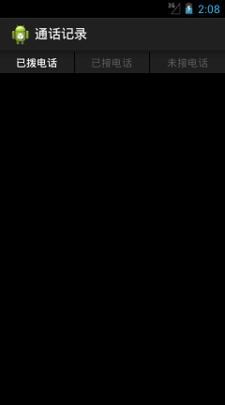
- 主界面
当前并没有通话记录，把应用关闭或按Home建进入后台，然后呼出一个电话，如图6-3所示。
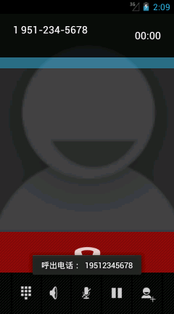
- 呼出电话
如图6-3所示，当呼出一个电话时，屏幕上会提示呼出的电话号码。接下来使用DDMS的Emulator Control功能对模拟器进行呼叫，并在模拟器上分别进行多次接听和挂断操作，如图6-4所示。
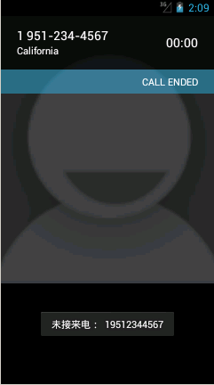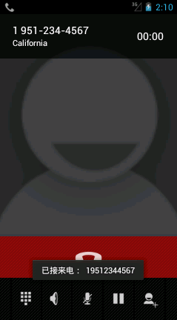
- 未接来电和已接来电
如图6-4所示，分别进行了挂断电话和接听电话的操作，都有界面提示，接下来再次打开应用，如图6-5所示。
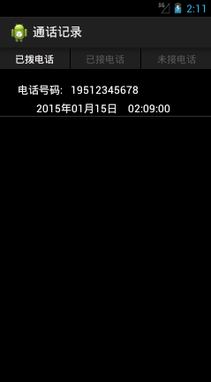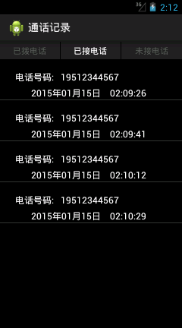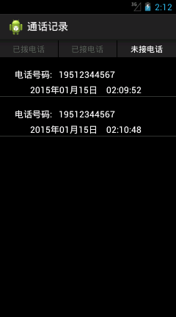
- 主界面
如图6-5所示，在进行了一系列操作之后主界面中显示出来之前对电话操作的状态，主界面默认显示已拨电话，点击已接电话和未接电话按钮会看到各自对应的记录。

三、案例总结
1、需要注意的是，使用广播接收者必须要在清单文件中进行注册。

案例6-2 BatteryLevel（电池电量）

一、案例描述
- 考核知识点
030006001：广播接收者简介
030006002：广播接收者的创建
- 练习目标
- 广播的动态注册和销毁
- 需求分析
广播分为两种注册方式：静态注册和动态注册，上一个案例讲解了静态注册，该案例将对广播进行动态注册与销毁。该案例主要讲解了监听设备的电量和网络状态并展示在界面上。
- 设计思路（实现原理）
- 在代码中进行监听电池电量和网络状态广播的注册和注销；
- 将获取到的状态显示在界面上。

二、案例实现
（1）编写主界面
创建“BatteryLevel”程序，首先创建MainActivity用于显示信息，该程序的界面如图6-6所示。
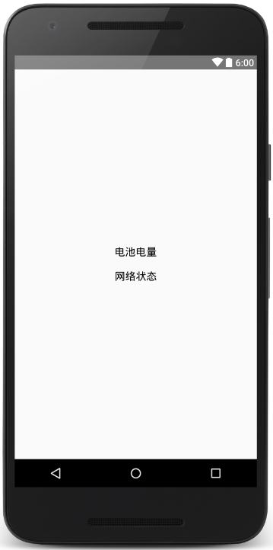
- 主界面
程序主界面对应的布局文件（activity_main）如下所示：
<?xml version="1.0" encoding="utf-8"?>
<RelativeLayout xmlns:android="http://schemas.android.com/apk/res/android"
xmlns:tools="http://schemas.android.com/tools"
android:layout_width="match_parent"
android:layout_height="match_parent"
tools:context=".MainActivity" >
<LinearLayout
android:layout_width="wrap_content"
android:layout_height="wrap_content"
android:layout_centerInParent="true"
android:orientation="vertical" >
<TextView
android:id="@+id/tv_cell"
android:layout_width="wrap_content"
android:layout_height="wrap_content"
android:text="电池电量"
android:textColor="#000000"
android:layout_margin="10dp"
android:textSize="18dp" />
<TextView
android:id="@+id/tv_netWork"
android:layout_width="wrap_content"
android:layout_height="wrap_content"
android:text="网络状态"
android:textColor="#000000"
android:layout_margin="10dp"
android:textSize="18dp" />
</LinearLayout>
</RelativeLayout>
（2）编写程序代码
编写好主界面，接下来编写MainActivity类逻辑代码，具体代码如下所示：
- package cn.itcast.batterylevel;
- import android.app.Activity;
- import android.content.BroadcastReceiver;
- import android.content.Context;
- import android.content.Intent;
- import android.content.IntentFilter;
- import android.net.ConnectivityManager;
- import android.net.NetworkInfo.State;
- import android.os.Bundle;
- import android.widget.TextView;
- import android.widget.Toast;
- public class MainActivity extends Activity {
- private TextView tv_cell, tv_netWork;
- private BatteryReceiver batteryReceiver;
- private ConnectivityReceiver connectivity;
- @Override
- protected void onCreate(Bundle savedInstanceState) {
- super.onCreate(savedInstanceState);
- setContentView(R.layout.activity_main);
- tv_cell = (TextView) findViewById(R.id.tv_cell);
- tv_netWork = (TextView) findViewById(R.id.tv_netWork);
- // 注册广播接受者java代码
- IntentFilter intentFilter = new IntentFilter(
- Intent.ACTION_BATTERY_CHANGED);
- batteryReceiver = new BatteryReceiver();
- // 注册receiver
- registerReceiver(batteryReceiver, intentFilter);
- IntentFilter mFilter = new IntentFilter();
- mFilter.addAction(ConnectivityManager.CONNECTIVITY_ACTION);
- connectivity = new ConnectivityReceiver();
- registerReceiver(connectivity, mFilter);
- }
- /**
- * 广播接受者
- */
- private class BatteryReceiver extends BroadcastReceiver {
- @Override
- public void onReceive(Context context, Intent intent) {
- // TODO Auto-generated method stub
- // 判断它是否是为电量变化的Broadcast Action
- if (Intent.ACTION_BATTERY_CHANGED.equals(intent.getAction())) {
- // 获取当前电量
- int level = intent.getIntExtra("level", 0);
- // 电量的总刻度
- int scale = intent.getIntExtra("scale", 100);
- // 把它转成百分比
- tv_cell.setText("电池电量为" + ((level * 100) / scale) + "%");
- }
- }
- }
- private class ConnectivityReceiver extends BroadcastReceiver {
- @Override
- public void onReceive(Context context, Intent intent) {
- State wifiState = null;
- State mobileState = null;
- ConnectivityManager cm = (ConnectivityManager) context
- .getSystemService(Context.CONNECTIVITY_SERVICE);
- wifiState = cm.getNetworkInfo(ConnectivityManager.TYPE_WIFI)
- .getState();
- mobileState = cm.getNetworkInfo(ConnectivityManager.TYPE_MOBILE)
- .getState();
- if (wifiState != null && mobileState != null
- && State.CONNECTED != wifiState
- && State.CONNECTED == mobileState) {
- Toast.makeText(context, "手机网络连接成功",
- Toast.LENGTH_SHORT).show();
- tv_netWork.setText("手机网络连接成功");
- // 手机网络连接成功
- } else if (wifiState != null && mobileState != null
- && State.CONNECTED != wifiState
- && State.CONNECTED != mobileState) {
- // 手机没有任何的网络
- Toast.makeText(context, "手机没有网络",
- Toast.LENGTH_SHORT).show();
- tv_netWork.setText("手机没有网络");
- } else if (wifiState != null && State.CONNECTED == wifiState) {
- // 无线网络连接成功
- Toast.makeText(context, "无限网络连接成功",
- Toast.LENGTH_SHORT).show();
- tv_netWork.setText("无限网络连接成功");
- }
- }
- }
- @Override
- protected void onDestroy() {
- super.onDestroy();
- unregisterReceiver(batteryReceiver);
- unregisterReceiver(connectivity);
- }
- }
（3）运行程序
运行“BatteryLevel”程序，结果如图6-7所示。
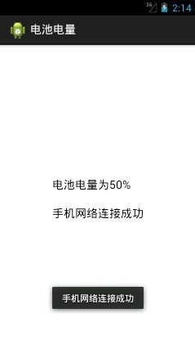
- 运行界面
如图6-7所示，运行程序之后，当前设备的电量和网络状态都显示在了界面上。

三、案例总结
1、广播可以进行静态注册和动态注册。
2、广播在代码中动态注册需要有unregisterReceiver()操作。

